Customer Engagement And Product Utilization Analytics

Prepared for: Unified Mentor — Financial Analyst Internship
Project: Customer Engagement And Product Utilization Analytics
Dataset: European Bank Customer Data (10,000 customers, France/Germany/Spain)

1. Abstract
Customer churn occurs when an existing customer ends their relationship with a service provider. In retail banking, churn can weaken customer lifetime value, reduce product relationships and create a need to acquire replacement customers. This project examines whether customer profile, account and activity variables can help identify patterns associated with bank customer exit. The project uses European_Bank.csv, containing 10,000 customer records and 14 original columns. The target variable Exited indicates whether a customer left (1) or stayed (0). Initial checks found zero missing values and zero duplicate rows. The dataset contains 7,963 retained customers (79.63%) and 2,037 churned customers (20.37%). Exploratory analysis was performed across geography, gender, age group, product count and active membership. The project heatmap showed approximate correlations of 0.29 between Age and Exited and -0.16 between Is Active Member and Exited.
A Logistic Regression baseline was fitted after removing identifier/administrative fields, encoding categorical features and applying a stratified 80:20 train-test split. The training set contained 8,000 rows and the test set contained 2,000. Because verified evaluation outputs were not available for this draft, no predictive performance value is claimed. The study concludes that descriptive patterns can inform further investigation, while operational prediction requires validation, threshold selection and monitoring.
Keywords: customer churn, retail banking, predictive modeling, Logistic Regression, risk scoring, retention, exploratory data analysis.

Introduction
Retail banks operate in a competitive environment where customers compare service quality, digital access, fees, product suitability and support. A customer who closes an account or ends the relationship is commonly described as churned. Churn may reflect several factors, including changing needs, product fit, service experience, financial circumstances or engagement.
Historical reporting describes customers after they have left. Predictive analytics attempts to identify patterns associated with future exit so that the bank can investigate and offer suitable support earlier. A model output is a risk estimate, not proof of why a customer leaves and not a guarantee of future behavior.

Importance of the Study
- Summarizes observed churn patterns across customer segments. Provides a structured
starting point for retention review.
- Demonstrates the combination of finance knowledge and data analytics. Encourages
transparent reporting and evaluation of model quality.

Key Terms
Churn means the recorded exit outcome. Retention means the customer has not exited. Classification predicts a class such as churn or retained. A probability score estimates the likelihood of an outcome between 0 and 1. A risk segment groups cases for review; it is not a definitive judgment about a customer.

Background And Problem Statement
Banks hold customer information that may include demographics, account characteristics, product holdings and activity indicators. Reviewing each customer manually can be resource-intensive. An analytical workflow can help summarize patterns and test whether a model ranks customers by estimated churn risk.

Problem Statement
The study asks whether the available customer-level variables can help distinguish churned from retained customers and whether the findings can support targeted
retention analysis. Without a properly evaluated model, apparently strong performance
can be misleading: a model may miss churners or incorrectly flag customers who would have
stayed.

Business Context
A useful retention process requires more than a binary prediction. It needs a sensible review queue, appropriate customer communication, clear error-cost trade-offs and a way to measure outcomes. Balance and product count can describe the relationship, but they do not alone measure profitability or explain a customer's decision.

Proposed Solution
The proposed workflow combines exploratory data analysis with Logistic Regression as a baseline classifier. Following evaluation, probabilities may be transformed to a 0–100 score and used to prioritize human review. Score bands should be selected using validation evidence and operational capacity, not presented as statistically proven before testing.

Objectives

Objectives

Inspect the structure and quality of the 10,000 record dataset. Measure the overall distribution
of churned and retained customers. Explore churn by geography, gender, age group, product
count and active membership. Examine selected correlations with the churn target.

Prepare features by excluding identifiers and encoding categorical variables. Fit a Logistic
Regression baseline using a stratified 80:20 split.

Define evaluation using a confusion matrix, precision, recall, F1-score and ROC-AUC.Describe
a validated probability-based risk-scoring workflow.

Recommend responsible next steps for retention analysis.

Expected Contribution
The contribution is a documented learning workflow and business-oriented interpretation. Descriptive findings are reported separately from predictive performance claims, which must await final model evaluation.

SCOPE

Scope
The study is limited to European_Bank.csv and the notebook workflow documented in Google Colab. It is observational and cross-sectional. It does not establish causality, measure the impact of a retention campaign or demonstrate live deployment.

Unit of Analysis
The unit of analysis is one customer record. Exited is binary: 1 represents churn and 0 represents retention. Customer identifiers and surname are excluded from model inputs.

Literature Review
Research on bank churn prediction has used statistical classification and machine-learning models based on demographic, account and behavioral variables. Since churn datasets often contain fewer churners than retained customers, studies commonly consider metrics beyond overall accuracy.

Logistic Regression
Logistic Regression estimates the probability of a binary outcome using a weighted combination of input features. It is a useful baseline because it is comparatively interpretable and can output probabilities. Results depend on data preparation, feature relationships, regularization, class balance and decision threshold.

Evaluation Beyond Accuracy
When retained customers dominate the data, a model can obtain apparently high accuracy by predicting the majority class too often. Precision measures the share of predicted churn cases that truly churned; recall measures the share of actual churners detected; F1-score balances precision and recall; ROC-AUC assesses ranking discrimination across thresholds.

Published Research Context
Chen, Liu and Wang (2023) studied machine-learning approaches to European bank customer churn and compared Logistic Regression with other classifiers. Their study illustrates the value of comparing models and examining recall and AUC. Those results belong to their experiment and must not be copied as results of this internship project.
A 2025 article in Discover Sustainability discusses ensemble-based bank churn prediction and class imbalance. Published work provides methodological context, but results depend on the dataset version, preprocessing, split and validation method.

Project Gap
This internship project emphasizes a transparent baseline that can be explained to a finance-oriented audience. Descriptive findings are available, and Logistic Regression was fitted; verified predictive evaluation is still required before model performance can be assessed.

Dataset Description
The working file is European_Bank.csv. Project records indicate 10,000 rows and 14 original columns. The data contains demographic, geographic, account and engagement-related attributes. Exited is the target variable.

Data Quality

Records | 10,000
Original columns | 14
Missing values in initial check | 0
Duplicate rows in initial check | 0
Retained | 7963 (79.63%)
Churned | 2037 (20.37%)

Main Variables

Variable | Role | Description
CreditScore | Numeric feature | Customer credit-score value
Geography | Categorical feature | Country group
Gender | Categorical feature | Recorded gender category
Age | Numeric feature | Customer age
Tenure | Numeric feature | Years with bank
Balance | Numeric feature | Recorded account balance
NumOfProducts | Count feature | Number of bank products
HasCrCard | Binary feature | Credit-card ownership indicator
IsActiveMember | Binary feature | Active membership indicator
EstimatedSalary | Numeric feature | Estimated salary
Exited | Target | 1 = churned; 0 = retained
CustomerID / Surname | Identifier | Excluded from modeling
Year | Administrative | Excluded in documented workflow

Research Methodology

Research Design
The study follows a quantitative, secondary-data analytics design. It combines descriptive statistics, visualizations and a supervised classification baseline. The work is exploratory, not causal.

Tools
Python and Google Colab for execution. pandas for tabular data handling.
Matplotlib/Seaborn for visualization.
scikit-learn for train-test splitting and Logistic Regression.

Workflow

Load the CSV and inspect rows, columns and data types. Check missing values and duplicate
rows. Review target distribution. Plot churn patterns across customer attributes.

Remove identifiers and administrative columns from inputs. One-hot encode categorical variables.

Create stratified 80:20 split using random_state=42. Fit LogisticRegression(max_iter=1000). Evaluate the held-out test set.

Document results, limitations and recommendations.

Train-Test Split
The documented split produced X_train with 8,000 rows and 12 encoded features, X_test with 2,000 rows and 12 features, and target arrays of 8,000 and 2,000 records. Stratification was used to preserve approximate class proportions.

Reproducibility
To reproduce the analysis, use the same dataset version, feature-removal logic, encoding, split parameters and model settings. Save the notebook and retain the final output of every evaluation cell.

Exploratory Data Analysis
Exploratory data analysis describes the structure of the dataset and highlights group differences. These are descriptive patterns and do not prove that any variable causes churn.

Overall Churn Distribution
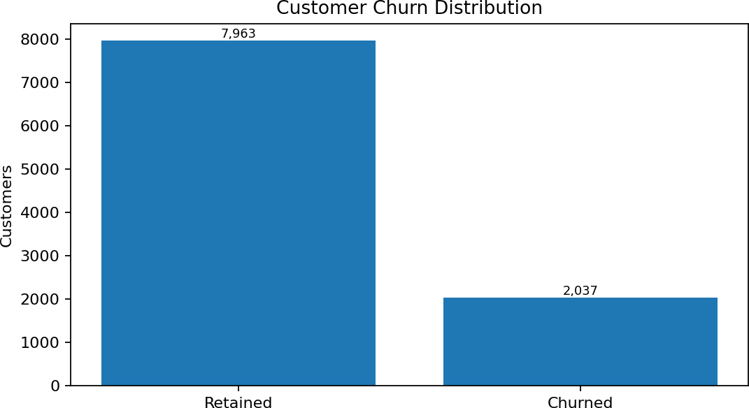

Figure 1. Retained and churned counts from the project dataset summary.
Of 10,000 records, 7,963 were retained and 2,037 churned. Churn is 20.37% and retention is 79.63%. Class imbalance makes recall and precision important when evaluating the model.

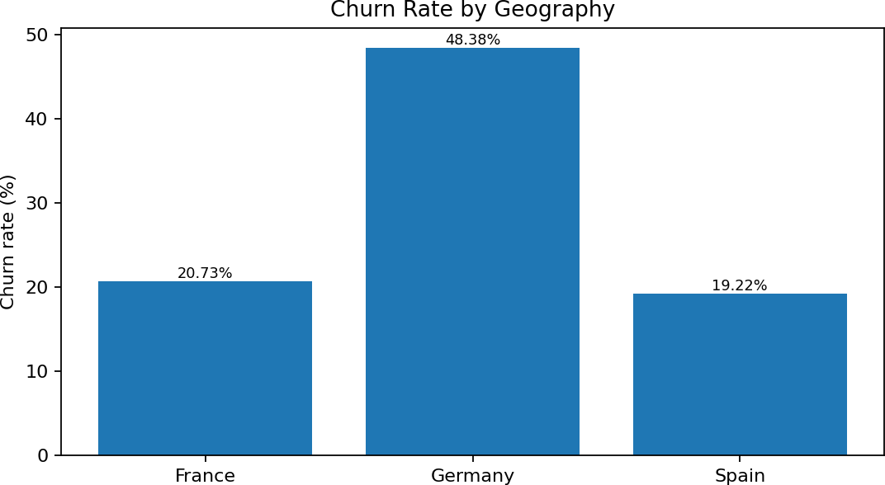
Geography

Figure 2. Reported churn rate by geography.
Reported churn rates are France 20.73%, Germany 48.38% and Spain 19.22%. Germany has the highest observed group-level rate in the available analysis. Check subgroup sizes and definitions before making recommendations.

Engagement Level
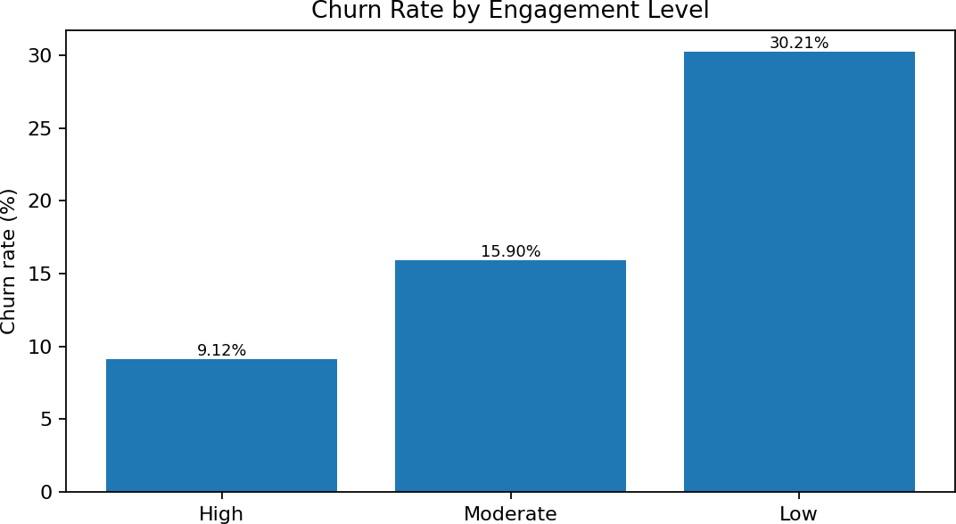
Figure 3. Reported churn rate by engagement level.
Reported churn rates are 9.12% for High engagement, 15.90% for Moderate and 30.21% for Low engagement. Low engagement is associated with higher observed churn in this dataset. Document the exact engagement definition before interpreting this operationally.

Number of Products

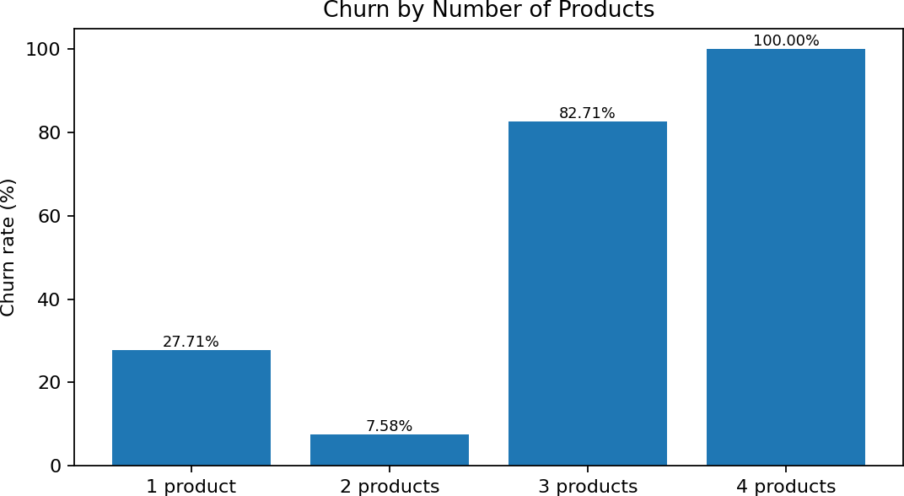

Figure 4. Reported churn rate by number of products.
Reported rates are 27.71% for one product, 7.58% for two, 82.71% for three and 100% for four products. The very high rates for three and four products should be interpreted carefully. Display subgroup counts and review data definitions before treating these estimates as stable.

Engagement Score and Retention

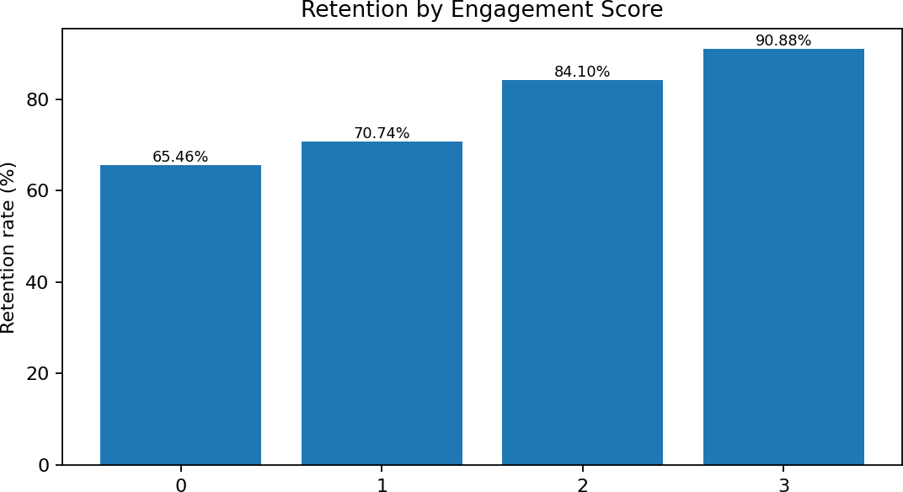

Figure 5. Reported retention rate by engagement score.

Reported retention rises from 65.46% at score 0 to 70.74% at score 1, 84.10% at score 2 and 90.88% at score 3. This is consistent with the engagement-level findings, but the score definition and subgroup sizes should be documented.

Correlation Review
The project's correlation heatmap showed approximate correlations of 0.29 between Age and Exited, -0.16 between IsActiveMember and Exited, 0.12 between Balance and Exited, -0.03 between CreditScore and Exited, and -0.05 between NumOfProducts and Exited.
These are simple correlations, not causal effects. A low linear correlation does not necessarily mean a variable is useless in a multivariable model.

High-Value, Low-Engagement Segment
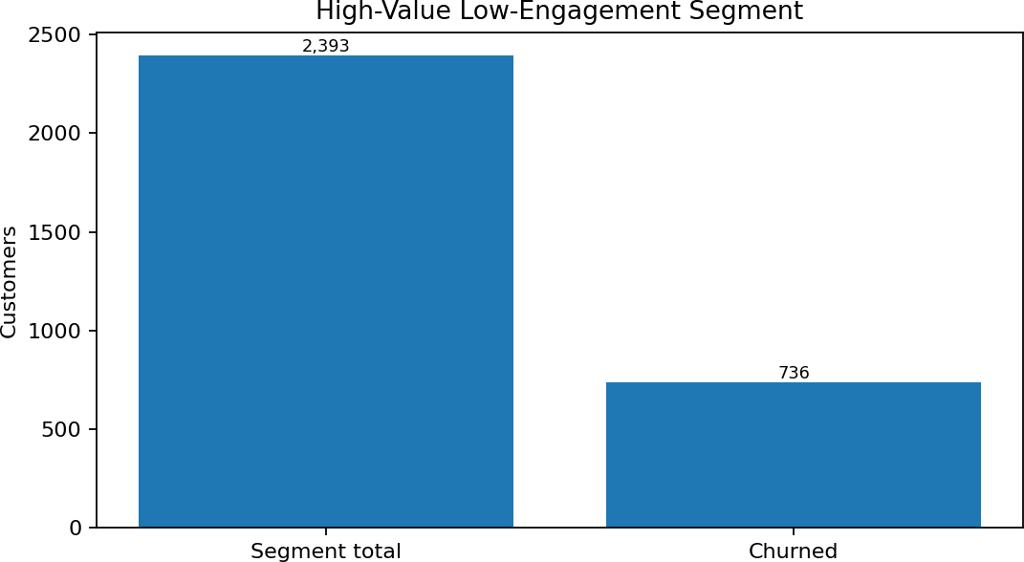

Figure 6. Previously reported segment: 2,393 customers, including 736 churned.

The project summary reported 2,393 customers in a high-value, low-engagement segment, including 736 churned customers and a churn rate of 30.76%. The reported balance threshold was 97,198.54. Reproduce the segment in the notebook before submission and confirm the exact threshold and engagement rule.
This is a descriptive segment, not a validated model output. Avoid claiming that it is a prediction unless generated from the fitted model and evaluated.

Findings And Interpretation

Main Findings

- 10,000 records were checked; initial checks found no missing values or duplicate rows.
20.37% of customers were recorded as churned.
- Germany had the highest reported churn rate among the three geographies. Low-engagement customers had higher reported churn than moderate- and
- high-engagement groups. Reported churn varied sharply by product count;
- high rates need subgroup-size checks.
- Age had a positive and active membership a negative correlation with Exited in the heatmap.
- The high-value, low-engagement segment contained 2,393 customers, including 736 churned (30.76%).

Finance-Oriented Interpretation
The results suggest that retention monitoring may benefit from segment-level analysis rather than treating the customer base as uniform. Geography, engagement and product holdings can be examined jointly. Account balance describes one part of a relationship, but does not alone measure profitability, lifetime value or the customer's reason for leaving.

What the Findings Do Not Establish

They do not establish causation or prove a retention intervention will work. They do not establish
the predictive performance of Logistic Regression. They do not prove subgroup rates will remain
stable

Predictive Modeling Framework

Target and Features
The target is Exited. The documented workflow removes Exited from the feature matrix and excludes CustomerID, Surname and Year as identifier or administrative fields. Geography and Gender are converted into numeric indicator columns using one-hot encoding with drop_first=True.

Logistic Regression
Logistic Regression estimates the probability of a binary outcome. A logistic function transforms a weighted combination of input features into a probability. A decision threshold then converts the probability to a predicted class. The project used LogisticRegression(max_iter=1000). The iteration setting supports convergence but does not guarantee high performance.

Current Evidence
The available project record confirms the model was fitted. It does not provide a final classification report, confusion matrix or ROC-AUC. Therefore, this paper makes no numerical claim about accuracy or other predictive performance.

Probability Versus Decision
A model-estimated probability is not a guarantee. Threshold selection should reflect the cost of missed churners, unnecessary outreach and retention-team capacity. The same threshold may not be suitable for every business context.

Model Evaluation Plan
The test set should be used to estimate generalization to records not used for fitting. Report the confusion matrix and classification report. Because classes are imbalanced, accuracy must not be the only metric.

Metric | Meaning | Purpose
Accuracy | Correct predictions / all predictions | Overall correctness, but may hide missed churne
Precision | True churn predictions / predicted churners | Shows how many flagged customers actually chu
Recall | Detected churners / actual churners | Shows how many churners were found.
F1-score | Harmonic mean of precision and recall | Balances precision and recall.
ROC-AUC | Ranking performance across thresholds | Measures discrimination between classes.
Confusion matrix | Counts of true/false positives and negatives | Shows error types explicitly.

These bands are illustrative placeholders, not empirically selected cutoffs. Evaluate calibration and precision/recall at different thresholds, consider team capacity and quantify the cost of false positives and false negatives.

Risk Score Controls

Use identical preprocessing at training and scoring. Do not use customer identifiers as model features.
Record model version and scoring date.
Do not use the score alone for denying products or changing terms. Monitor score distributions and
performance over time.

Business Recommendations

Segment Monitoring
Review churn by geography, engagement and product count periodically. Display subgroup counts beside every rate to distinguish stable patterns from rates based on few customers.

Engagement-Oriented Outreach
Low-engagement customers may warrant a helpful service check-in to understand digital-access issues, product fit or unresolved needs. Inactivity should not automatically be treated as dissatisfaction.

Geography-Specific Investigation
Germany has the highest reported rate in this dataset. First validate the subgroup size and churn definition, then investigate possible differences in products, service or customer experience. Do not generalize this result to all German customers or future periods without further evidence.

Product-Count Review
The high reported rates for three- and four-product groups require a sample-size check. Analysts should review counts, definitions and uncertainty before making product-specific recommendations.

Measure Retention Outcomes
Where feasible, evaluate a retention program through a controlled pilot. Track contact rates, retention outcomes, complaints and costs. A model may prioritize review, but suitable evaluation is needed to estimate whether an intervention improves retention.

Ethical Considerations And Limitations

Privacy
Customer data should be handled according to applicable privacy requirements and organizational policies. Avoid sharing names or identifiers in reports and screenshots unless authorized. This paper reports aggregate results rather than individual customer records.

Fairness and Explainability
Geography, gender and age may be sensitive or potentially sensitive in customer decisions. Their use requires legal, fairness and disparate-impact review before deployment. Model output should not be the sole basis for adverse decisions.

Limitations
The dataset is a single snapshot and may not represent current behavior. Associations do not
establish causal explanations.
Class imbalance can make a default threshold unsuitable. Logistic Regression may miss nonlinear patterns without feature engineering. Verified evaluation metrics have not been supplied in this draft.
Risk bands are illustrative and require validation. Subgroup rates may be
unstable when counts are small.
Live deployment and business-impact testing are outside the verified scope.

Generalizability
The findings apply to this dataset and should not automatically be generalized to other banks or time periods. Validation on later data and on the intended deployment environment would be necessary.

Conclusion And Future Scope
This project studies churn patterns and a preliminary predictive workflow using a 10,000-record European bank dataset. Initial quality checks found no missing values and no duplicate rows. The observed churn rate is 20.37%. Exploratory findings show higher reported churn in Germany, among low-engagement customers and in three- and four-product groups. These patterns merit investigation but require attention to group size, definitions and confounding factors.
A Logistic Regression baseline was fitted after removing identifier/administrative fields, encoding categorical variables and using a stratified 80:20 split. The test set contains 2,000 records. Since verified evaluation outputs were not available for this draft, no accuracy, precision, recall, F1-score or ROC-AUC is claimed. Completing that evaluation is the immediate next step.

Future Scope

- Complete model evaluation and report the actual confusion matrix and metrics.Check
probability calibration and select thresholds based on costs and capacity. Compare Logistic
Regression with tree-based baselines using consistent validation. Use time-based validation
if multi-period data becomes available.

- Document engagement definitions and segment rules. Build a dashboard only after model
performance and scoring logic are verified. Monitor drift, subgroup performance and retention
outcomes.

- Run a controlled pilot to evaluate whether targeted outreach improves retention.

References
Chen, P., Liu, N., & Wang, B. (2023). Evaluation of Customer Behaviour with Machine Learning for Churn Prediction: The Case of Bank Customer Churn in Europe. EAI Endorsed Transactions on AI and Robotics.
https://doi.org/10.4108/eai.28-10-2022.2328450
Discover Sustainability. (2025). Ensemble-based customer churn prediction in banking: a voting classifier approach for improved client retention using demographic and behavioral data.
https://link.springer.com/article/10.1007/s43621-025-00807-8
Dataset used in this project: European_Bank.csv, 10,000 records and 14 original columns, as provided in the internship project workspace. Add the exact dataset source/license if available.
Published studies provide methodological context only; their metrics are not results of this internship project.

Appendix A: Variable Dictionary

Variable | Type | Use
CreditScore | Numeric | Customer credit-score characteristic
Geography | Categorical | Compare observed churn by location
Gender | Categorical | Descriptive comparison; fairness review required
Age | Numeric | Demographic characteristic
Tenure | Numeric | Relationship duration
Balance | Numeric | Recorded account balance
NumOfProducts | Count | Number of products
HasCrCard | Binary | Credit-card ownership
IsActiveMember | Binary | Active membership
EstimatedSalary | Numeric | Estimated salary
Exited | Binary target | 1 = churned; 0 = retained
Year | Administrative | Excluded in documented workflow
CustomerID | Identifier | Excluded from model inputs
Surname | Identifier | Excluded from model inputs

Appendix C: Verified Model Metrics To Complete
This table is intentionally left blank until the final evaluation cell is run. Enter the actual output from the current notebook.

Metric | Verified result
Accuracy | To be entered from Google Colab
Precision for churn class (1) | To be entered from Google Colab
Recall for churn class (1) | To be entered from Google Colab
F1-score for churn class (1) | To be entered from Google Colab
Metric | Verified result
ROC-AUC | To be entered from Google Colab
True negatives | To be entered from Google Colab
False positives | To be entered from Google Colab
False negatives | To be entered from Google Colab
True positives | To be entered from Google Colab

